[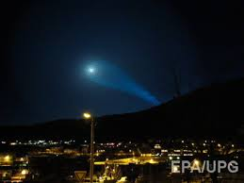](http://www.google.kz/imgres?imgurl=http://gordonua.com/img/article/621/21_tn.jpg&imgrefurl=http://gordonua.com/news/worldnews/V-internete-opublikovany-ranee-zasekrechennye-dannye-VVS-SSHA-ob-issledovaniyah-NLO-62121.html&h=285&w=380&tbnid=sr8Bd3CpOrP40M:&docid=UovajJP8ug2g9M&ei=bXThVa_6FcebsgHl3JzQCw&tbm=isch&ved=0CAsQMygIMAg4yAFqFQoTCO_kptb2zccCFceNLAodZS4Hug)[](http://www.google.kz/imgres?imgurl=http://magspace.ru/uploads/2014/05/21/21-00zFOGkGCkpzs.jpg&imgrefurl=http://magspace.ru/blog/intresting/258115.html&h=1024&w=789&tbnid=ZDLqZ5tn2Z7NrM:&docid=AHHe5XNmzIlgeM&ei=bXThVa_6FcebsgHl3JzQCw&tbm=isch&ved=0CAwQMygJMAk4yAFqFQoTCO_kptb2zccCFceNLAodZS4Hug)